*Version 2019-Spring-1.1, Revised 6 February 2019*

Activity 3.2:

Git – Navigation

This activity is to reinforce and review Git navigation. You have been using basic navigation commands for navigating the file system in GitLab in previous classes. This activity offers to review the steps that have been followed to do the same and refresh student’s knowledge.

Navigating Your File System at the Command Line

The files on your computer are stored in the ***file system***. Your computer has multiple tools that let you manipulate the file system and the files within it. These tools may have different representations of the file system and use different commands to do so.

In this activity we will look at using command line tools to navigate the file system.

## Content Learning Objectives

*After completing this activity, students should be able to:*

* Locate a file in their file system using command line tools.

## Process Skill Goals

*During the activity, students should make progress toward:*

* Leveraging prior knowledge and experience of other students. (Teamwork)

## Team Roles

*Decide what role each of you will play for today. Choose a role that you have not played before, or recently. The goal should be to have all team members rotate through the roles on a regular basis to become comfortable with all the roles. If you have only three people, one should have two roles. If you have five people, two may share the same role. Record role assignments here.*

|  |  |
| --- | --- |
| Manager |  |
| Presenter |  |
| Recorder |  |
| Reflector |  |

# Model 1: Lab1 Files using the Graphical User Interface (GUI)

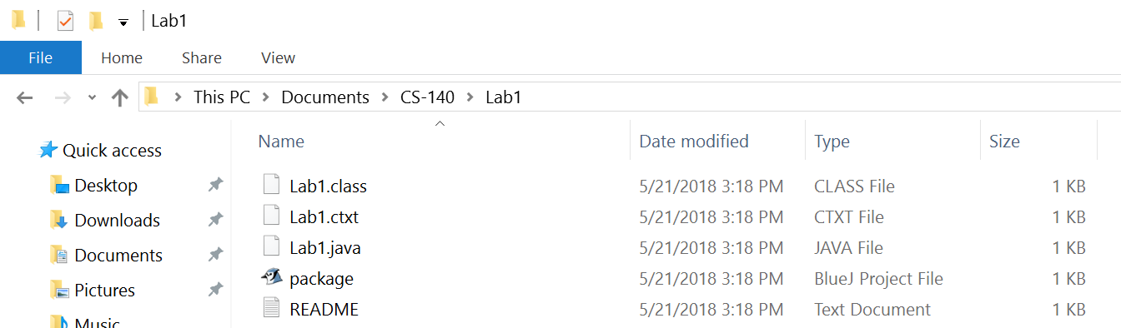

Lab1 on Windows

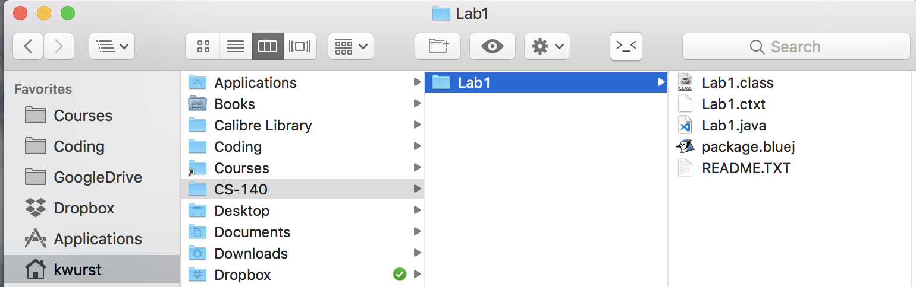

Lab1 on Mac OS

## Questions (2 min)

1. Where is the Lab1.java file on the Windows machine? Give the full path to the file.
2. Where is the Lab1.java file on the Mac? Give the full path to the file.

# Model 2: Starting a Command Line Interface

There are multiple programs that provide a command line interface. They are all slightly different from each other in appearance, even on the same operation system. But they have enough common features that we should be able to perform basic operations on any command line interface.

In a command line interface, you will interactive with the interface by typing commands (rather than pointing, clicking, and dragging.)

Here we are using **Git Bash** on Windows, and **Terminal** on Mac OS.

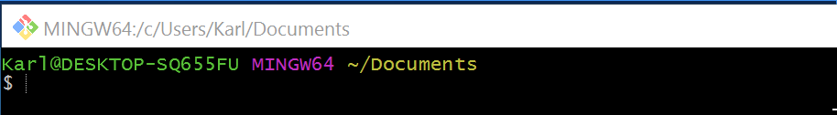

**Git Bash** on Windows



**Terminal** on Mac OS

## Questions (1 min)

1. What does the **$** in each of the interfaces indicate?

# Model 3: **pwd** Command



**Git Bash** on Windows



**Terminal** on Mac OS

## Questions (1 min)

1. What does the **pwd** command do?

# Model 4: **ls** Command



**Git Bash** on Windows

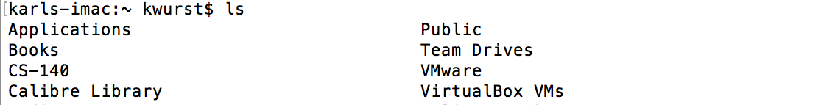

**Terminal** on Mac OS

## Questions (1 min)

1. What does the ls command do?

# Model 5: **cd** Command

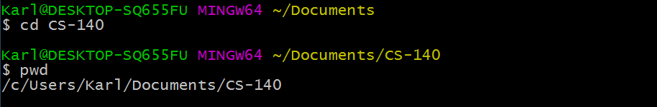

**Git Bash** on Windows



**Terminal** on Mac OS

## Questions (1 min)

1. What does the **cd** command do?
2. What is the purpose of the portion of the command that comes after the **cd**?

# Model 6: **cd ..** Command

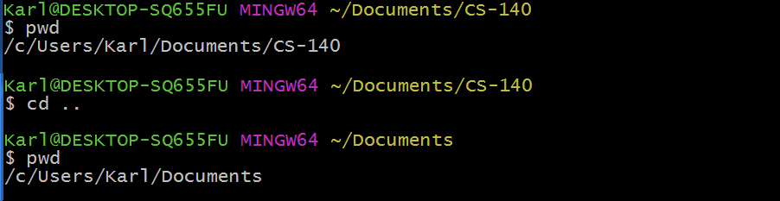

**Git Bash** on Windows

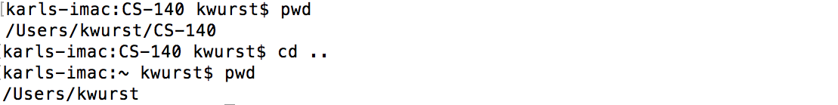

**Terminal** on Mac OS

## Questions (1 min)

1. What does **..** mean when used with the **cd** command?

Copyright © 2019 Karl R. Wurst. This work is licensed under a Creative Commons Attribution-ShareAlike 4.0 International License.